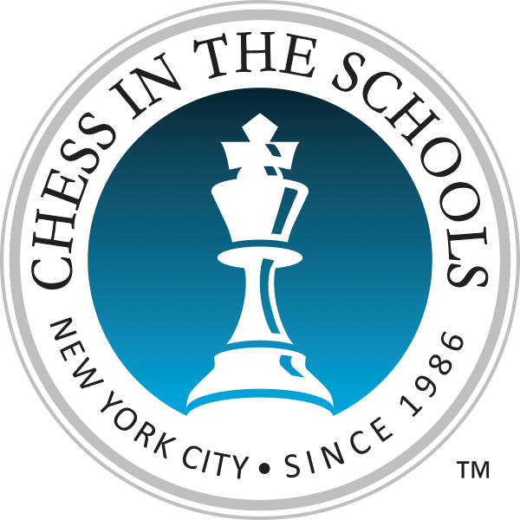
Chess in the Schools
2019-2020 Tournament Calendar

Date Tournament
September 14, 2019 19^{h} Annual Chess-in-the-Park Rapid Open, Central Park
October 5, 2019 Brooklyn Chess Day, PS 503k, Sunset Park
October 14, 2019 Columbus Day Tournament, 11m, Chelsea
October 26, 2019 Queens Chess Day, PS 150q, Sunnyside
November 2, 2019 Bronx Chess Day, MS 390x, Bronx
November 11, 2019 Veterans’ Day Tournament, 11m, Chelsea
November 16, 2019 Robert Cornegy Jr. Chess Challenge, 289K, Brooklyn
November 23, 2019 DYCD Chess Masters Tournament, PS 11m, Chelsea
December 7, 2019 Francisco Moya Chess Challenge, 329Q, East Elmhurst
December 14, 2019 Queens Chess Day, PS 150q, Sunnyside
December 17, 2019 Bronx Borough President’s Cup (School Day Event)
December 21, 2019 Brooklyn Chess Day, PS 503k, Sunset Park
January 11, 2020 Keith Powers Chess Challenge at 59M, Manhattan
January 20, 2020 MLK Jr. Day Tournament, 11m, Chelsea
January 25, 2020 Andy King Chess Challenge, 169x, Bronx
February 1, 2020 Francisco Cabrera Chess Challenge, MS 390x, Bronx
February 8, 2020 Brooklyn Chess Day, PS 503k, Sunset Park
February 29, 2020 Queens Chess Day, PS 150q, Sunnyside
March 7, 2020 2020 All Girls NYC Chess Championship, PS 11m,
March 21, 2020 Ben Kallos Chess Challenge, ERHS, Manhattan
April 4, 2020 Mathieu Eugene Chess Challenge, PS 139k, Brooklyn
May 2, 2020 Cullman Rookie Tnt., PS 11m, Chelsea
May 16, 2020 Bronx Chess Day, MS 390x, Bronx
May 30, 2020 Brooklyn Chess Day, PS 503k, Sunset Park

Calendar Subject to Change * Check tournament details and updates at www.chessintheschools.org

